Free Youtube views for an unlimited number of your videos! Boost your video's popularity using their simple and free method! Or, buy Youtube views and other services here.

[ythunder.com](https://ythunder.com/) has free & open registrations.

**Be VIRAL: 7 Steps To Have More** [**YouTube Subscribers**](https://ythunder.com/)**!**



All viral videos started with a subscriber. So what is a subscriber and how is it important?

A [YouTube](https://ythunder.com/) subscriber is a viewer who had chosen to follow your videos in [YouTube](https://ythunder.com/). They watch, Free Youtube views：[ythunder.com](https://ythunder.com/)

share and comment on videos that you post. By having a good subscriber base, it will be easier for you advertise your channel. And to do so, there are certain principles that you need to follow.

First, you need to be consistent. It's not a one-and-done thing. You have to post new videos as frequent as you can. Second, you need to provide value in your videos. Your videos must have excellent contents. If you have some effective strategies or well kept secrets, share them to your viewers. And lastly, be creative on how you make your videos. Make it as entertaining as possible because boring videos are a big no-no in [YouTube](https://ythunder.com/).Now, let's talk about how to double up your number of subscribers in your channel

**#1 Ask them to subscribe**

This is the easiest and most forgotten way to round up subscribers. All you have to do is simply ask viewers to click the "Subscribe" button. By doing so, they will be able to view your future videos.Free Youtube views：[ythunder.com](https://ythunder.com/)

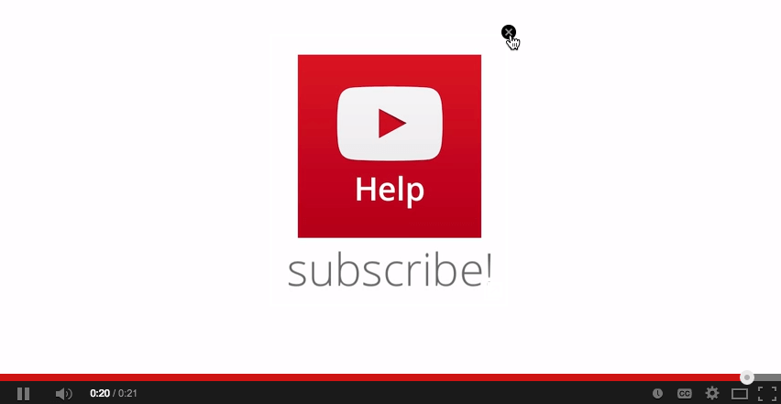

**#2 Use Annotations:**

Annotations are often taken for granted. These are overlaying text that contains links to the other videos. There are two kinds of annotations to help in your [YouTube](https://ythunder.com/) Marketing Campaign.First one is the call-to-action annotation. All you need to do is to add “speech bubbles” annotations under the “Subscribe" button in your videos.

The second one is the “click-to action” annotation. You can add an image or a graphics and overlay it with a “spotlight” annotation, so when the viewers click it, they will be directed to your other videos.

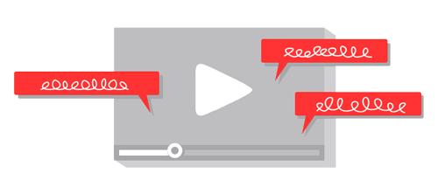

**#3 Add** [**YouTube**](https://ythunder.com/) **Widgets**

If you have a website, you can ask people to check your [YouTube](https://ythunder.com/) channel. Those people can become your subscribers. All you need to do is install the [YouTube](https://ythunder.com/) Subscription Widget in the side bar of your blog or website and paste widget code from the official [YouTube](https://ythunder.com/) Blog Post.



**#4 Create a Channel Trailer**

Creating a channel trailer is an interesting and promising way to get more subscribers for your channel and to introduce your channel. In making a good trailer, you have to have a clear “call to action” annotation, inviting your viewers to subscribe to your channel. Indicate what kind of file that you are going to upload and when you are going to upload it. It should be interesting, creative and with excellent content.

**#5 Make Friends**

[YouTube](https://ythunder.com/) is a community where you share your videos and interact with people. By making friends with other [YouTuber](https://ythunder.com/)s, you can have more people to view you channel. You can also get other subscribers by following other [YouTube](https://ythunder.com/) channels, leaving genuine comments and sharing and liking videos. [YouTuber](https://ythunder.com/)s generally help each other to garner subscribers



**#6 Make it a game**

People usually are competitive. Use this as a leverage to get more subscribers by rewarding them when they reach a certain number of subscriptions or views that you wish to attain.



**#7 Buy** [**YouTube Subscribers**](https://ythunder.com/)

To Buy [YouTube](https://ythunder.com/) subscriber is the fastest and easiest way to get subscribers. Buying subscribers can help you gather immediate subscribers. The higher the subscription rate, the more people will be influenced to subscribe. This phenomenon is called the social authority. People want to be in the popular group. So, when they see your subscribers, people will be compelled to subscribe because it’s something popular.

Viral videos don’t happen overnight. They simply become viral because of that little "Subscribe" button you might have been ignoring the whole time.

**Author - Sheena Mathieson**



Sheena Mathieson, understands the essence of making excellent content that suits the needs of every business especially when it comes online marketing with social media. She can spice up your marketing campaign with the content she makes on how to make most out of [youtube views](https://ythunder.com/), facebook likes, etc. and then incorporate Buy Real Marketing services

**back...**Free Youtube views for an unlimited number of your videos! Boost your video's popularity using their simple and free method! Or, buy Youtube views and other services here.

[ythunder.com](https://ythunder.com/) has free & open registrations.